Report On Tallaringa/Mamungari (Unnamed Conservation Park) Working Trip 29/05/2007-8/06/2007

The reason for the crossing of the desert was designated as a reconnaissance trip to establish further work that could be undertaken in future trips, coupled with the opportunity to pursue further study of Quadrants established on the group’s previous trip in 2006.

Department For Environment And Heritage Support
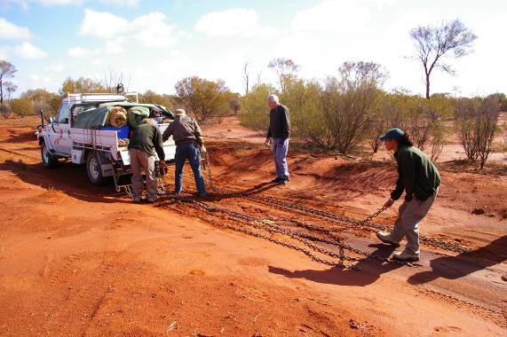
Ceduna office provided a vehicle driven by Ranger, Andy Causebrook and Trainee Ranger Tammy Cox to precede the convoy dragging chains to eliminate corrugations. Port Augusta Office was represented by Ranger, Kristian Coulthard who supported the Tallaringa working team. They also provided a barbecue meal and drinks at Tallaringa Well. The Friends Of The Great Victoria Desert are most appreciative of this assistance.

The organisation and planning of the trip was undertaken by Terry Friebe. Doug Smith was team leader of the Tallaringa Conservation Park workers while Harold Ross had agreed to lead and supervise the working party in Mamungari Conservation Park (Formerly The Unnamed Conservation Park.).

On the morning of the 31st, because of illness, 2 members of the team had to return to Coober Pedy while Kristian Coulthard and 8 members of the group remained at Tallaringa Well and the Ceduna rangers, Andy and Tammy and 8 members of the party departed from Tallaringa Well to cross the desert to Serpentine lakes.

Work in Tallaringa
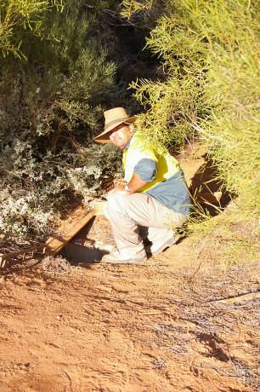
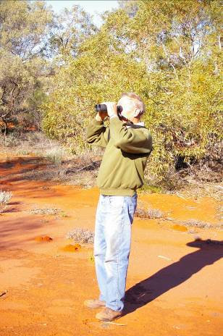
Whilst the two working groups were in Tallaringa time was spent setting up a quadrant, an area of 2hectares to survey and record plants and birds in the immediate area. Early morning i.e. 8am surveys of birds were also undertaken. Ten different birds were sighted on the test area totalling 44 species for the Tallaringa area.

The Tallaringa Well site was visited and rubbish was collected. Assessment was also made of future work that can be undertaken.

During their survey the Tallaringa group was given an insight into the old and the new. They discovered an automatic solar powered rain gauge. Kristian being familiar with this piece of modern equipment explained that after 2mm of rain it empties itself and records the results on a graph. Once a year the information is removed and sent to the Meteorology Office.
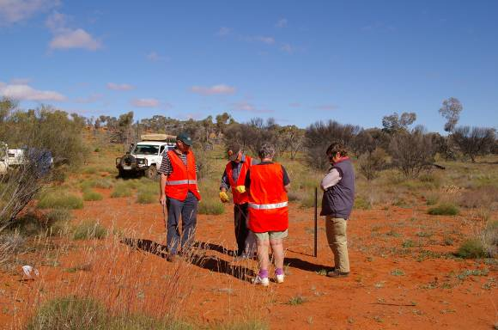
A report on recommended work that can be undertaken in the future will be included in the group’s final official report.

The Mamungari Working Party
This party continued along the Anne Beadell Highway to Serpentine Lakes and then returned to Voakes Hill Corner and proceeded down the Cook Road to the Dey Dey Road and to Oak Valley before proceeding to Colonna and the Eyre Highway. Along the way they continued to resurvey Quadrants that had been set up during the 2006 working trip resulting in twelve Quadrants being surveyed during the trip. This group also repositioned the seven new vegetation posts that had either been destroyed by fire or had weathered over the years.

During this trip a collection of plant species was gathered. Two samples were collected of each species and one will be kept by the State Herbarium whilst the remainder will be returned to the Friends of the GVD for cataloguing. Because these samples were collected when an opportunity arose it amounts to an opportunistic survey.
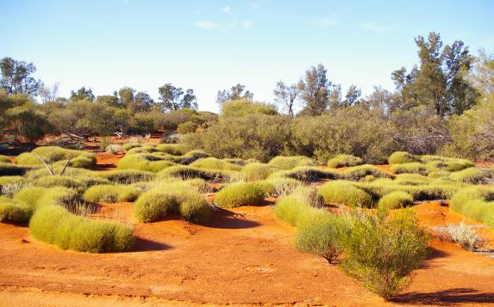
Desert Conditions

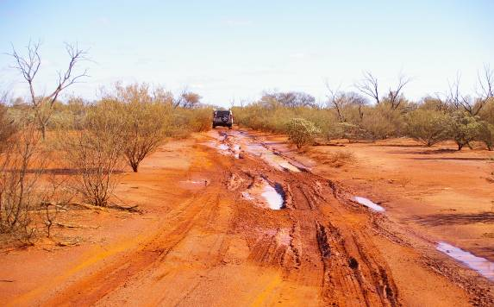
Prior to reaching the Dog Fence the convoy was detouring around a water covered track and so the party was optimistic of good conditions within the desert and as they progressed they were not disappointed. Along the way they were treated to displays of very green mounds of Triodia (Spinifex). In fact at times it was so thick and dense it resembled thick carpets. At other times it was in flower with beautiful purplish heads.

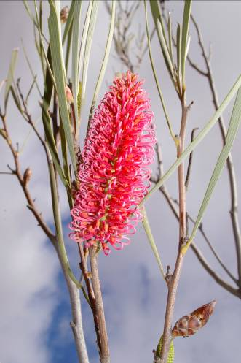
The once burnt desert was regenerating. Marble Gums – Gongylocarpa and Mallees were sprouting at ground level from root stock and young Hakea francisianas were well established. Some of the more established plants were in flower. From time to time the party stopped to photograph the beautiful golden/yellow Grevillia juncifolias as well as the cream of the other species of Grevillia. Although it was late/early in the season different species of Eremophilas were also displaying purple, mauve and red. At other times we were treated to splashes of Acacia yellow.
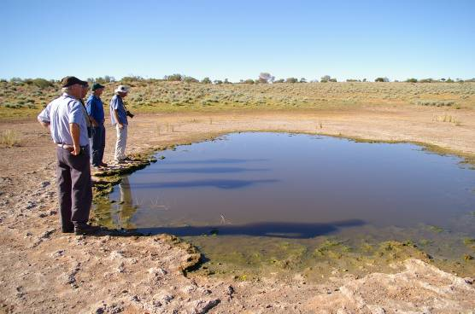
As we approached Tjintirrgarra Water Hole a Grey Teal duck waddled out of the water and up into the vegetation. Serpentine Lakes partially covered in water was quite spectacular and the feeding grounds for Red Capped Plovers and Grey Teal ducks.
Hakea francisiana
Tjintirrgarra Water Hole

Track Conditions
Track conditions for this area were predictably rough. However with Andy and Tammy travelling in front of the convoy and dragging chains conditions were not quite as bad as they have been in the past. In particular the chains removed much of the corrugations in the sandy areas and improved travelling in the more stony sections of track.

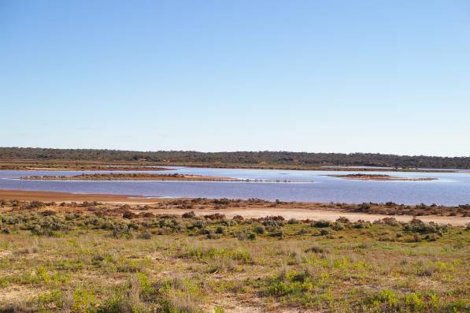
Seventy Kilometres from Tallaringa our convoy came across a vehicle that had broken a spring. This group was employing good 4WD procedure and consisted of a party of four vehicles. When the mishap occurred the occupants of two vehicles had gone to obtain replacement springs whilst the third remained with the damaged truck. They had constructed a detour around the offending vehicle to enable other traffic to safely pass and being a happy positive, experienced group they had a plan in place should rescue not occur within a prescribed time.

Several days later as our convoy was returning to Voakes Hill we came across the group who had repaired the vehicle and were proceeding on their way towards Serpentine Lakes. Fortunately the driver had obtained 2 springs as the second one broke within 40km of the first breakdown.
Serpentine Lakes

Weather
Except for a wind storm accompanied by thick dust at Coober Pedy and very cold evenings and mornings (-1ºC) on sunrise the group was treated to lovely mild to sunny, warm days.

To assist with this report Doug Smith supplied notes on the Tallaringa working party.
This report has been compiled by Marlene Friebe. Photography by Marlene Friebe.

