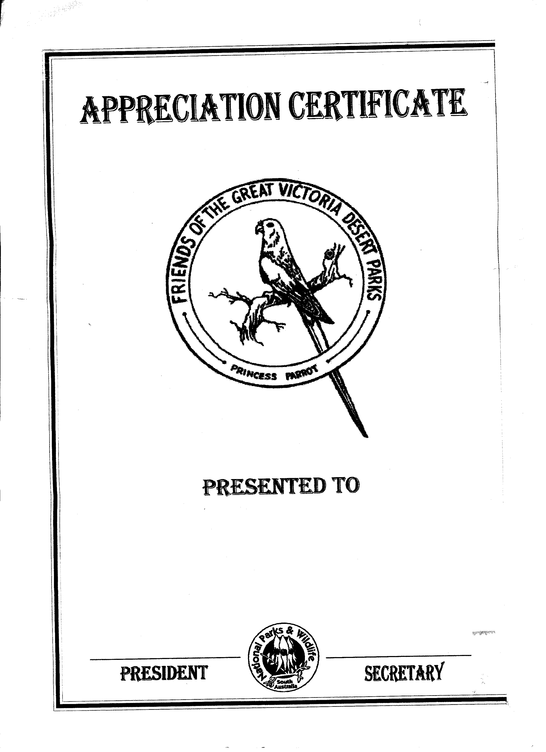
Report on the Unnamed Conservation Park Working Party
July 25th to August 5th 2005.
Compiled by Arlene Dowling
President

Twenty one members, including some from Victoria, attended the working Party, travelling more than two thousand kilometres from Ceduna to Ceduna, plus travel to and from home, in eleven private vehicles. GVD members contributed 2520 hours of voluntary labour including travel time to the park.

OUTCOMES

- The major work undertaken was the field identification and photography of specimens for our plant identikit book to be published in 2006. The plant descriptions were also “road tested” for accuracy. Numerous specimens were collected for the State Herbarium.

- Some 30-40 kilometres of roadside vegetation were cut back to allow safer travel within the park.

- 10-15 campsites were cleaned and roadside rubbish collected along the Anne Beadell Highway and other tracks.

- The interpretive signs were checked for accuracy and condition following major fires in the park.

- Links with the traditional owners were greatly enhanced. The group visited the Oak Valley Community which has joint responsibility for management of the Unnamed Conservation Park. We were shown the school and the aged care centre, strengthening our understanding of the community’s culture and its vision for the future of the Park. Strong ties were forged with Aboriginal administrator Chris Dodd, who camped out with the group on our last night in the area.

6. Our knowledge and understanding of the area was greatly extended by a tour of the Maralinga sites, the presence of experienced amateur botanists and a very informative ‘Quiz night’ prepared by two members.

COMMENTS

The Friends group worked under the direction of Senior Ranger Brett Dalzell, Ceduna Office. He arranged permission for us to enter the Maralinga lands and village, and the Oak Valley Community and acted as our liaison officer in both locations. His presence was invaluable both as a leader and group member because of his knowledge of the area and his willingness to help in every situation.

We are pleased to report that the park is in very good condition especially following recent “chaining” of the Vokes Hill - Serpentine Lakes track by NPWS staff. The only exception was recent amounts of soft rubbish left by a large group in both WA and SA campsites.

An average of 6 vehicles passed through each day and all had the relevant permits. Members were pleased to note there has been little increase in hard rubbish since their major clean-up in 1997.

We noted there were three campsites in the exclusion zone, and that several interpretative posts had been destroyed by fire.

RECOMMENDATIONS FOR FRIENDS OF THE GVD PARKS

- Future working parties to be planned in greater detail, with the Friends taking a more pro-active role in the planning and OHS requirements.

- That the working party and DEH staff conduct a debriefing at completion of each trip to structure future working groups.

- Finalise publication, publicity and distribution of the plant identikit book.

- Re-write the brochure and information sheet to reflect hand-over to traditional owners, availability of the plant identikit and changes to the interpretive trail signage.

- Develop a web site to promote work and publications of the group.

- Use existing boxes at Vokes Hill and Serpentine Lakes and erect one at the Eastern border for copies of our brochures and bird lists.

- Investigate the provision of park hosts for the mid-year school holiday period.

- Plan with DEH for the extension of our work to other parks within our brief e.g. Yumbarrra, Pureba and Yellabinna.

- Continue our contact with the Senior Ranger, Oak Valley Community to ensure we are represented in joint management decisions.

- Discuss with DEH and others the future plans for the Tallaringa Park as it is now managed out of the Port Augusta office.

RECOMMENDATIONS FOR CONSIDERATION BY DEH AND JOINT MANAGEMENT BOARD

- Increase management presence in the park during the mid-year school holiday period.

- Reinforce restrictions on large groups travelling through the park.

- GPS and publicise existing casual campsites on the Vokes-hill Serpentine Lakes road to deter travelers from cutting new ones into the bush. Advise map makers of these.

- Bollard dune access in existing campsites to prevent further incursions.

- Clean up campsites and provide signage in the exclusion zone to deter future campers.

6 Block off road wash-aways on Vokes Hill to Serpentine Lakes track for safety and to prevent further damage by vehicles.

7 Support the distribution of our plant identikit book throughout DEH.

8 Adopt the Objectives of the Draft Volunteer Strategy “Success Through Partnership”, in particular those relating to training, finances and staff resources to ensure that the volunteering experience is mutually beneficial.

