Common Name Scientific Name

Emu Dromaius novaehollandiae
Malleefowl Leipoa ocellata
Stubble Quail Coturnix pectoralis
Pink-eared Duck Malacorhynchus membranaceus
Grey Teal Anas gracilis
Hoary-headed Grebe Poliocephalus poliocephalus
Australasian Grebe Tachybaptus novaehollandiae
Australian Pelican Pelecanus conspicillatus
Black-shouldered Kite Elanus axillaris
Black Kite Milvus migrans
Collared Sparrowhawk Accipiter cirrhocephalus
Brown Goshawk Accipiter fasciatus
Little Eagle Hieraaetus morphnoides
Wedge-tailed Eagle Aquila audax
Spotted Harrier Circus assimilis
Swamp Harrier Circus approximans
Brown Falcon Falco berigora
Nankeen (Australian) Kestrel Falco cenchroides
Peregrine Falcon Falco peregrinus
Australian Hobby Falco longipennis
Grey Falcon Falco hypoleucos
Australian Bustard Ardeotis australis
Little Button-quail Turnix velox
Bar-tailed Godwit Limosa limosa
Wood Sandpiper Tringa glareola
Black-winged Stilt Himantopus himantopus
Red-necked Avocet Recurvirostra novaehollandiae
Red-capped Plover Charadrius ruficapillus
Black-fronted Dotterel Elseyornis melanops
Banded Lapwing Vanellus tricolor
Inland Dotterel Charadrius australis
Silver Gull Larus novaehollandiae
Common Bronzewing Phaps chalcoptera
Crested Pigeon Ocyphaps lophotes
Major Mitchell’s (Pink) Cockatoo Cacatua leadbeateri
Galah (both red and grey eye-ring) Eolophus roseicapilla
Purple-crowned Lorikeet Glossopsitta porphyrocephala
Princess (Alexandra’s) Parrot Polytelis alexandrae
Cockatiel Nymphicus hollandicus
Western (Port Lincoln) Ringneck Barnardius zonarius
Blue Bonnet Northiella haematogaster
Mulga Parrot Psephotus varius

Birds of the Mamungari Conservation Park

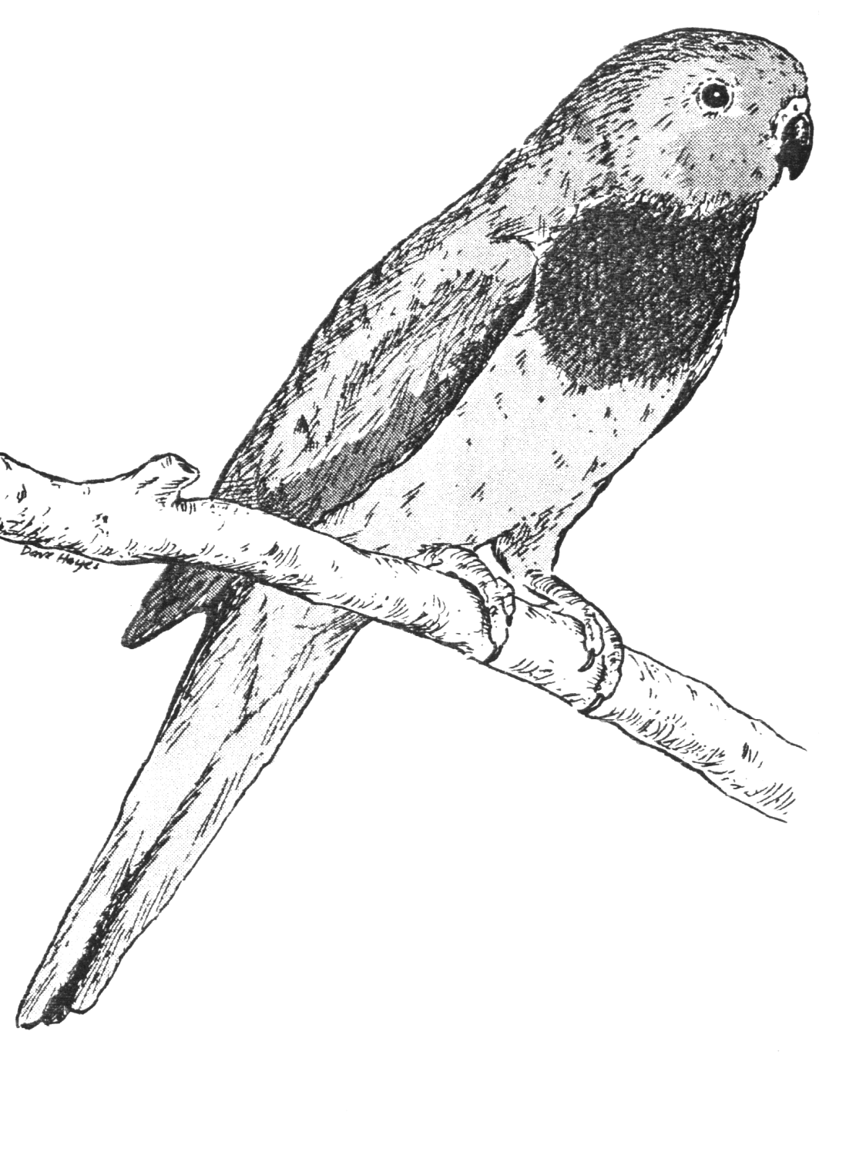


Scarlet-chested Parrot

Compiled by Friends of the Great Victoria Desert Parks

December 2007

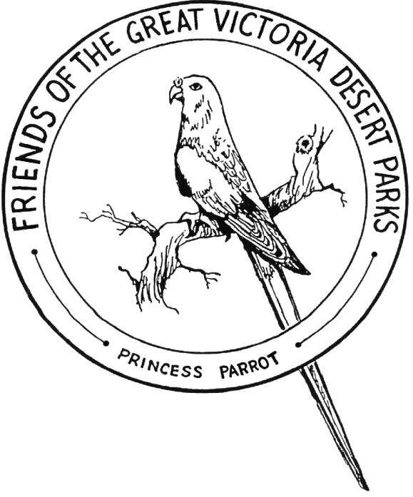

Common Name Scientific Name

Bourke’s Parrot Neopsephotus bourkii
Scarlet-chested Parrot Neophema splendida
Budgerigar Melopsittacus undulatus
Pallid Cuckoo Cuculus pallidus
Horsefield’s Bronze-Cuckoo Chrysococcyx basalis
Black-eared Cuckoo Chrysococcyx osculans
Southern Boobook Ninox novaeseelandiae
Barn Owl Tyto alba
Tawny Frogmouth Podargus strigoides
Australian Owlet-nightjar Aegotheles cristatus
Spotted Nightjar Eurostopodus argus
Fork-tailed Swift Apus pacificus
Red-backed Kingfisher Todiramphus pyrrhopygia
Rainbow Bee-eater Merops ornatus
White-browed Treecreeper Climacteris affinis
Rufous Treecreeper Climacteris rufa
Splendid Fairy-wren Malurus splendens
Variegated Fairy-wren Malurus lamberti
White-winged Fairy-wren Malurus leucopterus
Striated Grasswren Amytornis striatus
Red-browed Pardalote Pardalotus rubricatus
Striated Pardalote Pardalotus striatus
Redthroat Pyrrholaemus brunneus
Rufous Fieldwren Calamanthus campestris
Western Gerygone Gerygone fusca
Inland (Broad-tailed) Thornbill Acanthiza apicalis
Slaty-backed Thornbill Acanthiza robustirostris
Slender-billed (Samphier) Thornbill Acanthiza iredalei
Chestnut-rumped Thornbill Acanthiza uropygialis
Yellow-rumped Thornbill Acanthiza chrysorrhoa
Weebill Smicrornis brevirostris
Southern Whiteface Aphelocephala leucopsis
Spiney-cheeked Honeyeater Acanthagenys rufogularis
Yellow-throated Miner Manorina flavigula
Singing Honeyeater Lichenostomus virescens
Grey-headed Honeyeater Lichenostomus keartlandi
Grey-fronted Honeyeater Lichenostomus plumulus
White-fronted Honeyeater Phylidonyris albifrons
Grey Honeyeater Conopophila whitei
Black Honeyeater Certhionyx niger
Pied Honeyeater Certhionyx variegatus
Crimson Chat Ephthianura tricolor

Common Name Scientific Name

Orange Chat Ephthianura aurifrons
White-fronted Chat Epthianura albifrons
Jacky Winter Microeca fascinans
Red-capped Robin Petroica goodenovii
Hooded Robin Melanodryas culcullata
White-browed Babbler Pomatostomus superciliosus
Chiming Wedgebill Psophodes occidentalis
Chestnut Quail-thrush Cinclosoma castanotus
Varied Sittella Daphoenositta chrysoptera
Crested Bellbird Oreoica gutturalis
Gilbert’s Whistler Pachycephala inornata
Rufous Whistler Pachycephala rufiventris
Grey Shrike-thrush Colluricincla harmonica
Willie Wagtail Rhipidura leucophrys
Grey Fantail Rhipidura fuliginosa
Black-faced Cuckoo-shrike Coracina novaehollandiae
Ground Cuckoo-shrike Coracina maxima
White-winged Triller Lalage sueurii
White-browed Woodswallow Artamus superciliosus
Masked Woodswallow Artamus personatus
Black-faced Woodswallow Artamus cinereus
Little Woodswallow Artamus minor
Grey Butcherbird Cracticus torquatus
Pied Butcherbird Cracticus nigrogularis
Magpie-lark Grallina cyanoleuca
Australian Magpie Gymnorhina tibicen
Torresian Crow Corvus orru
Little Crow Corvus bennetti
Western Bowerbird Chlamydera guttata
Richard’s Pipit Anthus novaeseelandiae
Zebra Finch Taeniopygia guttata
Mistletoebird Dicaeum hirundinaceum
White-backed Swallow Cheramoeca leucosternus
Brown Songlark Cinclorhamphus cruralis
Rufous Songlark Cinclorhamphus mathewsi

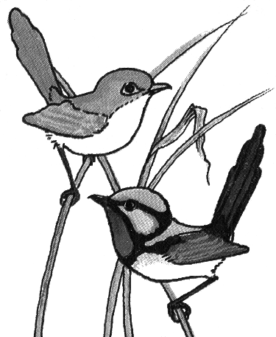
Sketch with kind permission of Queensland University Press.
Variegated Fairy-wren
Sketch with kind permission of Queensland University Press.
Variegated Fairy-wren
Sketch with kind permission of Queensland University Press.

